Mobile Computing Class Project Final Report

CSCI 4500/6970 Mobile Computing Fall 2020

# Introduce your UI Design and describe your UI elements (e.g., the functions of every button, etc.)

We have designed our IOS application by using 6 Scenes in Main.Storyboard and 1 Launch Screen Scene in LaunchScreen.Storyboard.

* The 6 Scenes in Main.Storyboard are as below:
  + Navigation Controller Scene
  + Browse Genre and Search Movie (Home Screen)
  + Search Movie Scene (To enter the movie name, type and year)
  + Browse Genre Scene To enter the Content year and Content Genre)
  + Results View Controller Scene (When we click on the search button on Search Movie Scene this scene includes result of Search Scene like Movie Title, image, year and IMDB link and When we click on the search button on Browse Genre Scene this scene includes result of Search Scene like Movie Title, image, year)
  + IMDb Website View Controller Scene (It is browser scene which shows the IMDB page of the movie.)
  + The LaunchScreen.Storyboard as one View Controller Scene which as UIImage View Element to show an IMDB logo while launching the application.

**UI ELEMENTS:**

To add interactivity to a user interface, providing touchpoints for the user as they navigate their way around; think buttons, scrollbars, menu items and checkboxes User Interface (UI) were used.

* We used below UI Elements in our Application
  + **UILabel**: Used for displaying static content.
  + **UIText Field:** UI element that enables the app to get user input.
  + **UIView**: UIView provides a structure for drawing, laying out sub views, and handling events within a rectangular region of its parent in the view hierarchy.
  + **UINavigationBar**: Contains the navigation buttons.
  + **UINavigationItem**: To be represented on the navigation bar, a navigation item must have a title.
  + **UIButton**: Used for handling user actions.
  + **UIImageView**: Used to display a simple image or sequence of images.
  + **UIScrollView**: Used to display content that is more than the area of screen.
  + **WKWebView**: Displays embedded web content and enables content navigation.
  + **UIPickerView**: It can be used to make a selection from multiple choices (similar to what a dropdown does for a webpage).
  + **CocoaPods:** CocoaPods manages library dependencies for your XCode projects. The dependencies for your projects are specified in a single text file called a Podfile. CocoaPods will resolve dependencies between libraries, fetch the resulting source code, then link it together in an XCode workspace to build your project.
  + **IQKeyboardManagerSwift:** Often while developing an app, we ran into an issues where the iPhone keyboard slides up and cover the *UITextField/UITextView*. IQKeyboardManager allows you to prevent issues of the keyboard sliding up and cover *UITextField/UITextView* without needing you to enter any code and no additional setup required.

# Introduce your design of mobile application, e.g., MVC models, UML diagrams, etc.

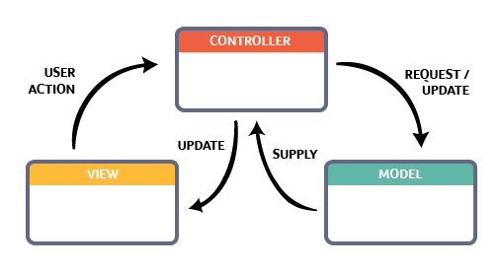

# Please attach your design of the UI (Hand-drawn sketch or Wireframe) along with this report. (You do not need to copy it here.)

# Please attach your codes (application) or a GitHub link to your project along with this report. (You do not need to copy it here.)

<https://github.com/Harish-Annapureddy/Mobile_Computing_Final_Project>

# Input/Output (take screenshots from your apps)

* 1. Screenshot of Home page:

In this page we can see Browse Genre thumbnail and Search Movie thumbnail which can differentiate the search results.

* 1. Screenshots of Browse Genre Scene:

In this page we can see Searching Options based on Content Year and Content Genre and Navigating option to the Home Page.

* 1. Screenshot of Search Movies Scene:

In this page we can search the movie by Title, Type and Year with a Search Key. By giving the required details we can click the search button and we will go to the next scene. It even contains a Navigation key to Home.

*Example:*

* 1. Screenshot of Browse Movie Genre Result Scene:

In this page we will get the search result of Browse Genre result by the given inputs.

* 1. Screenshot of Search Movie Result:

We can see a IMDB button in the above screenshot and by clicking the button we will get this information of the desired movie in the web.

